**Module 8 Student Questions**

## Observation Experiments: Looking at FFTs of Sinusoidal Time-Domain Signals - Guided Inquiry Questions

1. Have a lab partner set up any sinusoidal function they desire with the function generator and view it on the oscilloscope. Sketch the time-domain signal (i.e., the voltage versus time plot you see on the scope). Then have the scope show the FFT of this signal and sketch what you see to the right of your time-domain plot.
2. Have a lab partner increase the frequency of the sinusoidal function. Below your previous sketches, sketch the time-domain signal and the resulting FFT.
3. Have a lab partner increase the amplitude of the sinusoidal function. Below your previous sketches, sketch the time-domain signal and the resulting FFT.
4. From your observations, what do you think the FFT is plotting (i.e., which parameters do the x- and y-axes seem to correspond to?)
5. Match up the three time-domain signals below with their corresponding FFTs.

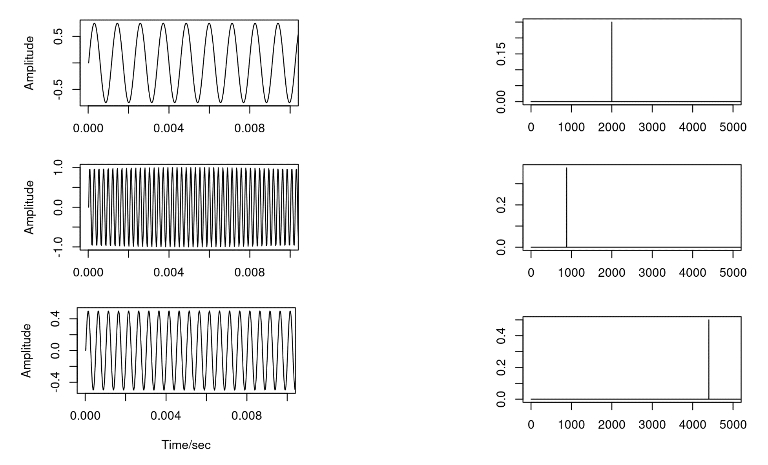

## Testing Experiment: Expanding Beyond Sinusoidal Functions - Guided Inquiry Questions

Let’s consider the following hypothesis:

The Fourier transform plots the amplitude versus the frequency of an inputted sinusoidal function.

1. If the time-domain signal is the sinusoidal function given below, and the hypothesis above is true, sketch your prediction of the resulting FFT.

[](https://www.codecogs.com/eqnedit.php?latex=s(t)%20%3D%205%20%5Csin(2%5Cpi%5Ccdot%20%5Ctextrm%7B200%20Hz%7D%20%5Ccdot%20t)#0)

1. If the time-domain signal is instead a sum of two sinusoidal functions given below, sketch your prediction of the resulting FFT. *This case isn't exactly covered in our hypothesis above, so you may need to give an expanded hypothesis to explain your prediction.*

[](https://www.codecogs.com/eqnedit.php?latex=s(t)%20%3D%205%20%5Csin(2%5Cpi%5Ccdot%20%5Ctextrm%7B200%20Hz%7D%20%5Ccdot%20t)%20%2B%2010%20%5Csin(2%5Cpi%5Ccdot%20%5Ctextrm%7B100%20Hz%7D%20%5Ccdot%20t)#0)

1. Design and perform an experiment that can test the hypothesis given above. Write a brief summary of the experiment you performed, your results, and your conclusions regarding this hypothesis.

## Observation Experiment: Exploring the FFTs of Periodic Time-Domain Signals - Guided Inquiry Questions

1. Sketch both the time-domain signal and the resulting FFT of your periodic but non-sinusoidal waveform.
2. What does the FFT of this periodic waveform suggest about how these periodic functions may be related to sinusoidal functions?

To further explore the relationship between periodic functions and sinusoidal functions, we will use the following Desmos calculator: <https://www.desmos.com/calculator/gjpuxeuwbj>. There are two variables (*N* and *L*) that you can set by clicking on the sliders below.

1. Observe what happens when you increase *N*. What do you think *N* is controlling?
2. What is happening to the frequency and amplitude of each of the blue sinusoidal functions that get added as you increase *N*?
3. Observe what happens when you increase *L.* What do you think *L* is controlling?
4. The red trace is the sum of all the sinusoidal blue traces shown. How can you adjust the settings to make the red trace better approximate a square wave?
5. Based on your answer above, sketch your prediction of the FFT of a square wave.
6. Alice and Sayed have come up with the following hypothesis regarding periodic functions:

All periodic functions *P(t)* can be written as an infinite sum of sinusoidal functions with different frequencies and amplitudes, such as

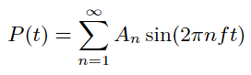

Is this hypothesis supported or disproved by what you have observed experimentally and learned from the Desmos calculator for the square wave?

## What Information Does the Fourier Transform Provide? - Guided Inquiry Questions

1. How does the exponential decay of a sinusoidal time-domain signal appear to impact the height and width of the Fourier transform peak?
2. As the signal decays faster (i.e., shorter T2* relaxation time), does the width of the peak in the frequency spectrum decrease or increase? Does this match with the following description of the cause of T2* relaxation - the spins in the sample are seeing different magnetic field environments and thus have slightly different precession frequencies that cause them to dephase. Explain your reasoning.

## Reflection Questions

1. Where else might being able to gather frequency information from time-domain signals be useful? *You can* [*watch this video*](https://www.youtube.com/watch?v=aqa6vyGSdos)*, linked in the Example Real-World Application, to get some ideas.*

2. Why might MR scientists primarily look at frequency spectra instead of the directly acquired time-domain data?

**The following questions make use of the figure below.**

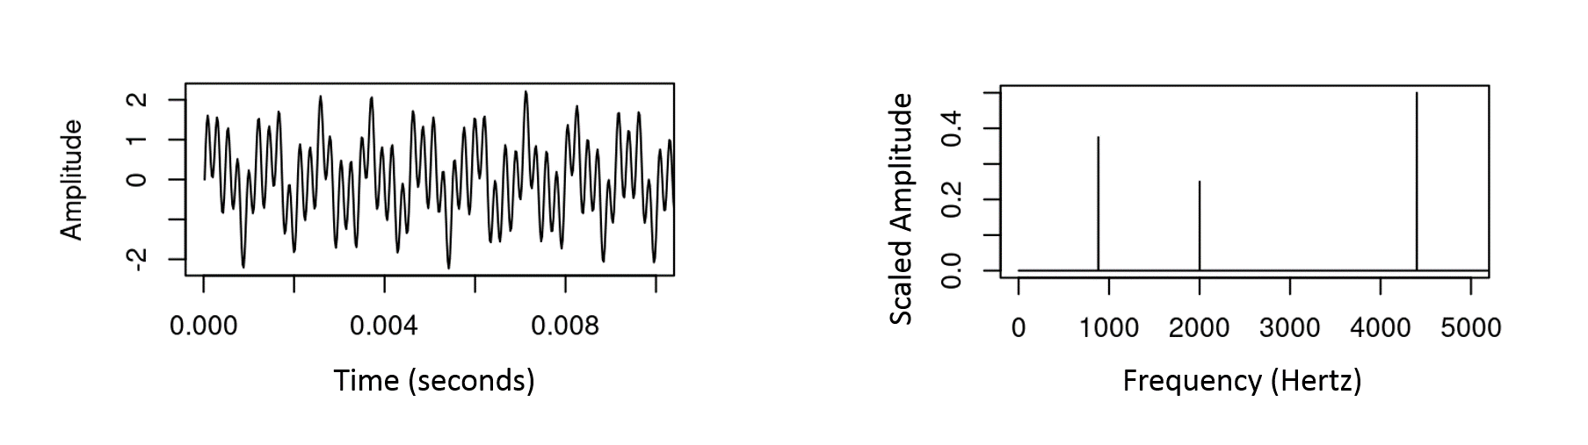

3. What approximate frequencies are present in the periodic signal shown in the figure above?

4. Do all the frequencies contribute equally to the signal? Why or why not?

5. Write a possible mathematical equation for the time-domain signal, assuming it is a sum of multiple sinusoidal functions. Please use a form similar to the many [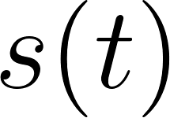](https://www.codecogs.com/eqnedit.php?latex=s(t)#0) functions given in the text.

**Follow this rubric to assess your work for this module:**

| **Scientific Ability** | **Adequate** | **Needs improvement** | **Inadequate** | **Missing** |
| --- | --- | --- | --- | --- |
| **Identify what information the Fourier transform provides about a periodic signal** | Identifies the correct information that the Fourier transform provides about a periodic signal. | Identifies some correct information with minor errors or  omissions. | The information described is  irrelevant or inconsistent with the data. | No attempt is made to  Identify information |
| **Use the provided equipment to acquire time-domain data and show the FFT** | All of the chosen measurements can be made, and all details about how they are  done are provided and clear. | All of the chosen measurements can be made, but the details about how they are done are vague or incomplete. | All of the chosen  measurements can be made, but no details are given about  how it is done. | Could not use the equipment to acquire the desired data. |
| **Sketch the frequency spectra that correspond to a simple sinusoidal time-domain signal in either graphical or equation form** | Sketch contains all key items with correct labeling of all physical quantities, has consistent subscripts, and axes are drawn and labeled correctly. | Sketch has no incorrect  information, but has either no or  very few labels of given quantities.  The majority of key features are drawn. | Sketch is drawn, but it is incomplete, or  important information is  missing, or it contains the wrong  information, or coordinate axes are missing. | No sketch is made. |